

**ASSIGNMENT – Terraform**

**Trainer – Pinkesh**

## Employ ID: CEQ441

**Employ Name**: Aarushi Sharma

**Mail ID**: aarushi.sharma@cloudeq.com

Step 1 create a main.tf file

step 2 – open terminal and configure your aws account

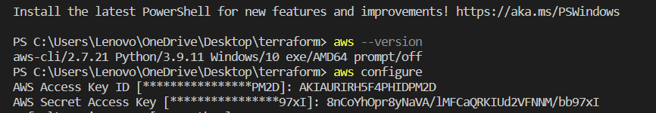



Step 3 – change directory and perform terraform init command for initialing the backup

Step 4- command terraform plan and the terraform apply

Step 5 – EC2 instance is created

Step 6 – to create a variable block and save it

Make changes in the main.tf file

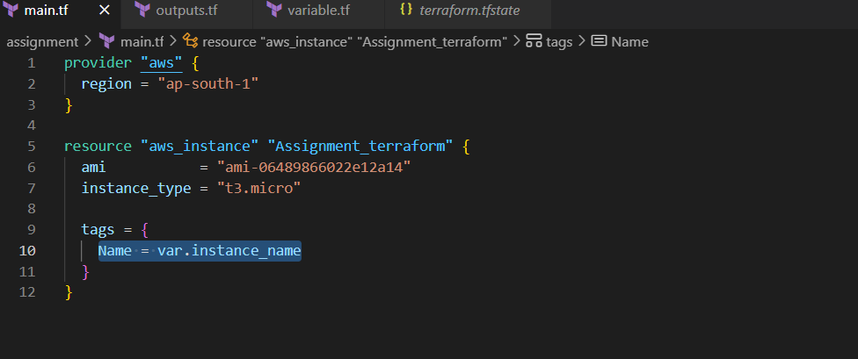save changes an apply terraform apply command to initialize the changes

Step 7 -Now apply the configuration again, this time overriding the default instance name by passing in a variable using the -var flag. Terraform will update the instance's Name tag with the new name. Respond to the confirmation prompt with

How to create an output.tf file

Step 1 – make a new file called output.tf and add code

Add values of the EC2 ID and instance public ID to the code

Step 2 – save the file and configure terraform init command

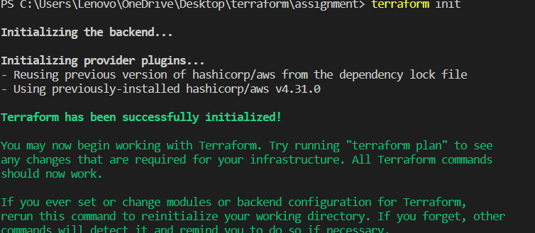

Step 3- configure terraform apply

How to use count function

Step 1 – add count to the resource block and the number of copies you want to make

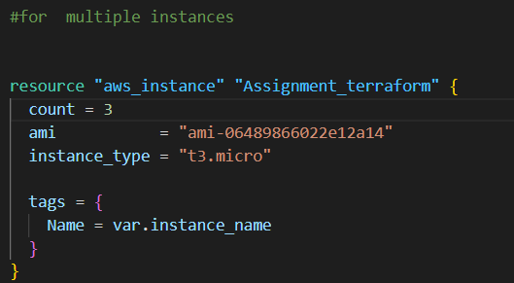

Step 2 – configure plan command and then terraform apply

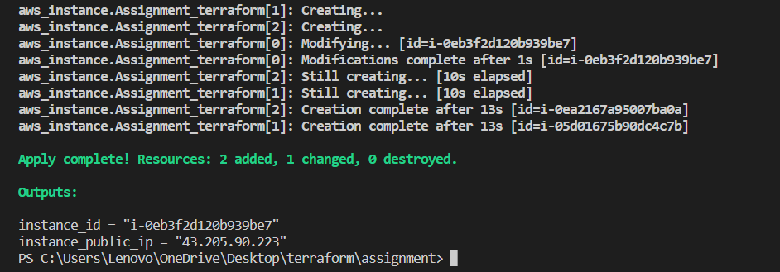

Check In aws console

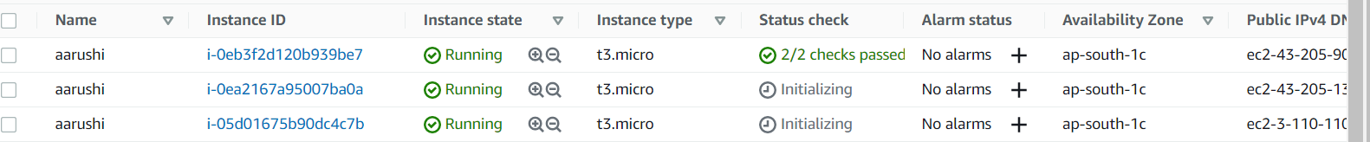

Created a Second resource -S3 bucket

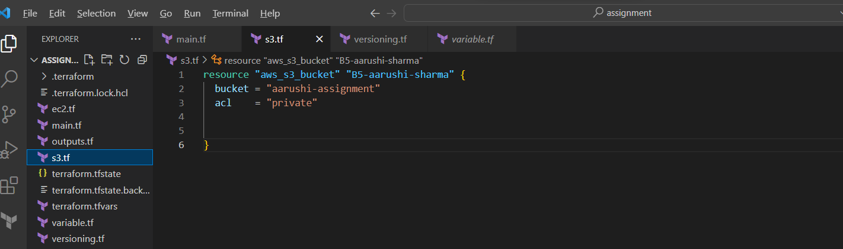



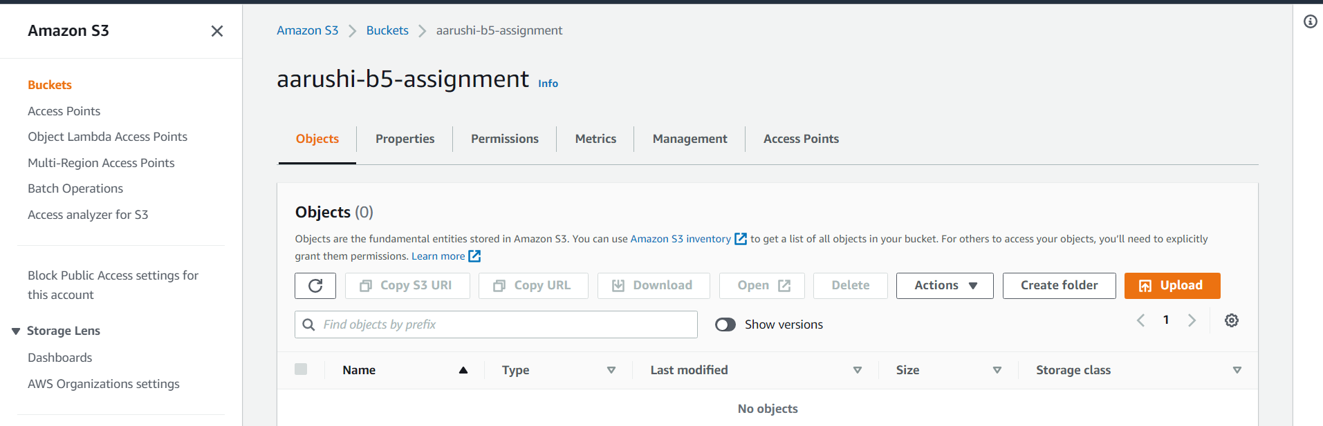

Create a versioning.tf file

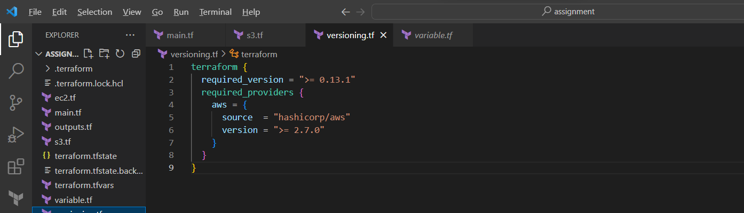

Backend configuration

Using the bucket we created earlier and create a DynamoDB table and add the values to the configuration and initialize it .